TL Module 2: Curriculum & Assessment

Unit 2: Internet Search Engines – Advanced Searching

Objectives:
Teachers should be able to use a search engine (UNESCO ICT-CFT, TL.4.f).

Duration:
Total of 3 notional hours – 2 hours computer practical session, 1 hour self-study preferably at a computer.

A] Computer Practical (Total 2 Hours)

Notes to Facilitator
Participants will need to have access to a computer with Internet connectivity. The facilitator should be on hand to provide support as required and the participants should be encouraged to liaise with their peers to solve problems, wherever possible. Participants will build on the knowledge that they acquired in Module 1 in order to develop an understanding of Boolean Logic and the way in which it can be used to refine search skills and techniques.

In Module 1, Unit 1, you learnt the basics about the Internet and searching. You were given an opportunity to complete a basic activity on searching the WWW. In this unit you are going to build on this knowledge by developing an understanding of Boolean logic and the way in which it can be used to refine searching skills and techniques.

The best way to refine your searching skills and techniques is to ensure that you understand the basics of Boolean logic. Take some time to understand the basics by reading through the resources below.

Boolean Logic
The Internet is a vast computer database. As such, its contents must be searched according to the rules of computer database searching. Much database searching is based on the principles of Boolean logic. Boolean logic refers to the logical relationship among search terms, and is named for the British-born Irish mathematician George Boole. On Internet search engines, the options for constructing logical relationships among search terms often modify the traditional practice of Boolean searching.

Activity 1: Reading (30 Minutes)
Read through the resources below.
- Boolean Searching on the Internet
- How Boolean Logic Works
- Basic Search Tips and Advanced Boolean Explained
- Boolean Search

Now that you have an understanding of Boolean Logic, you need to know how it can be applied in order to generate successful search results.

Activity 2: Online Tutorial on ‘Basic Search Techniques’ (30 Minutes)
The tutorial is a ‘how to’ guide for creating searches on Web search engines. Although the Google search engine is used as an example, keep in mind that the illustrated searches will work on most general search engines on the Web.
- Complete Tutorial [CC BY-NC]

We've explored some basic search techniques and these should cover many of your search needs. Yet there is much more available. Many search engines offer a variety of other options to help you retrieve the results you want. Google, in particular, offers all kinds of specialty searches.

Activity 3: Online Interactive Tutorial ‘Google Guide – Experienced Users’ (1 Hour)
Google Guide is an online interactive tutorial and reference for users. The guide provides detailed information about Google’s capabilities, features and services. The tutorial may appear to describe basic concepts, but if you read and work through it carefully, you’ll discover helpful insights into how Google works and how to use it more effectively.

Complete the following sections of the Google Guide interactive tutorial ‘Part I: Query Input’:
- Interpreting Your Query [CC BY-NC]
- Crafting Your Query [CC BY-NC]
- Google’s Advanced Search Form [CC BY-NC]
- Using Search Operators [CC BY-NC]

B] Self-Study (Total 1 Hour)
The following self-study activity will provide you with an opportunity to experiment with Boolean searching. You will begin to identify the way in which the search results returned differ as a result of the key word or words used. You will need access to a computer with Internet connectivity in order to complete the activities.

Task 1: Understanding and Using Boolean Operators [CC BY-NC]
Complete the activities below.

- Visit www.google.com and type in the following search terms. In the results column, list the title of the first three results that come up.

AND logic
Search Terms | Results
Poverty
Crime
poverty AND crime

- Visit www.google.com and type in the following search terms. In the results column, list the title of the first three results that come up.

OR logic
Search Terms | Results
College
University
college OR university
college OR university OR campus

- Visit www.google.com and type in the following search terms. In the results column, list the title of the first three results that come up.

NOT logic
Search Terms | Results
Cats
Dogs
cats NOT dogs

- Go to www.google.com and type in the following search terms. In the results column, list the title of the first three results that come up.

Search Terms | Results
(cats OR dogs) AND rabies
cats OR dogs AND rabies

- Go to www.google.com and type in the following search terms. In the results column, list the title of the first three results that come up.

Search Terms | Results
gray NEAR cats
gray AND cats

- Go to www.google.com and navigate to the advanced search section. Type ‘apple’ in the ‘all these words:’ search field and ‘mac’ into the ‘any of these unwanted words:’ search field.
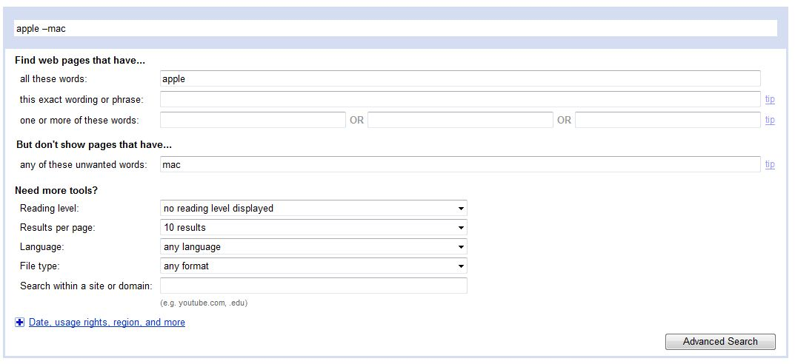
  - Which operator do you think the Google Advanced Search is making use of?
A: AND
B: OR
C: NOT
D: NEAR

- Go to www.google.com and navigate to the advanced search section. Type ‘Policy Document’ into the ‘Search within a site or domain’ search field.
  - Consider when it would be useful to search within a site or domain.

Resources Used in this Lesson Unit

Cohen, L. (2011). Internet Tutorials – Your Basic Guide to the Internet. Retrieved from http://www.internettutorials.net/.

Blachman, N, & Peek, J. (2008). Google Guide – Experienced Users. Retrieved from http://www.googleguide.com/experienced_users.html.

Alabama Dept. of Education. (2011). Alabama Learning Exchange (ALEX). Retrieved from http://alex.state.al.us/lesson_view.php?id=11203.

Cohen, L. (2011). Internet tutorials – your basic guide to the internet. Retrieved from http://www.internettutorials.net/.
Cohen, L. (2011). Internet Tutorials – Your Basic Guide to the Internet. Retrieved from http://www.internettutorials.net/.
Blachman, N, & Peek , J. (2008). Google guide - experienced users. Retrieved from http://www.googleguide.com/experienced_users.html.
Alabama Dept. of Education. (2011). Alabama learning exchange. Retrieved from http://alex.state.al.us/lesson_view.php?id=11203.

